**Digital Design and Computer Organization Laboratory**

**UE20CS206**

**3rd Semester, Academic Year 2021-22**

Date: 10-11-21

|  |  |  |
| --- | --- | --- |
| Name : SUNDEEP A | SRN : PES1UG20CS445 | Section : H |

Week : 7

**Title of the Program: Control Unit**

**Code:**

**In mproc.v file:**

module ir (input wire clk, reset, load, input wire [15:0] din, output wire [15:0] dout);

  dfrl dfrl_0 (clk, reset, load, din['h0], dout['h0]);

  dfrl dfrl_1 (clk, reset, load, din['h1], dout['h1]);

  dfrl dfrl_2 (clk, reset, load, din['h2], dout['h2]);

  dfrl dfrl_3 (clk, reset, load, din['h3], dout['h3]);

  dfrl dfrl_4 (clk, reset, load, din['h4], dout['h4]);

  dfrl dfrl_5 (clk, reset, load, din['h5], dout['h5]);

  dfrl dfrl_6 (clk, reset, load, din['h6], dout['h6]);

  dfrl dfrl_7 (clk, reset, load, din['h7], dout['h7]);

  dfrl dfrl_8 (clk, reset, load, din['h8], dout['h8]);

  dfrl dfrl_9 (clk, reset, load, din['h9], dout['h9]);

  dfrl dfrl_a (clk, reset, load, din['ha], dout['ha]);

  dfrl dfrl_b (clk, reset, load, din['hb], dout['hb]);

  dfrl dfrl_c (clk, reset, load, din['hc], dout['hc]);

  dfrl dfrl_d (clk, reset, load, din['hd], dout['hd]);

  dfrl dfrl_e (clk, reset, load, din['he], dout['he]);

  dfrl dfrl_f (clk, reset, load, din['hf], dout['hf]);

endmodule

module control_logic (input wire clk, reset, input wire [15:0] cur_ins, output wire [2:0] rd_addr_a, rd_addr_b, wr_addr, output wire [1:0] op, output wire pc_inc, load_ir, wr_reg);

  assign rd_addr_a[0] = cur_ins[0];

  assign rd_addr_a[1] = cur_ins[1];

  assign rd_addr_a[2] = cur_ins[2];

  assign rd_addr_b[0] = cur_ins[3];

  assign rd_addr_b[1] = cur_ins[4];

  assign rd_addr_b[2] = cur_ins[5];

  assign wr_addr[0] = cur_ins[6];

  assign wr_addr[1] = cur_ins[7];

  assign wr_addr[2] = cur_ins[8];

  assign op[0] = cur_ins[9];

  assign op[1] = cur_ins[10];

  wire t1,t2,t3;

  or3 o1(cur_ins[11],cur_ins[12],cur_ins[13],t1);

  or3 o2(cur_ins[14],cur_ins[15],t1,t2);

  invert o3(t2,t3);

  dfsl g1(clk,reset,1'b1,pc_inc,load_ir);

  dfrl g2(clk,reset,1'b1,load_ir,pc_inc);

  and2 o4(pc_inc, t3,wr_reg);

endmodule

module mproc (input wire clk, reset, input wire [15:0] ins, output wire [15:0] addr);

  wire pc_inc, cout; wire [2:0] rd_addr_a, rd_addr_b, wr_addr; wire [1:0] op; wire [15:0] cur_ins, d_out_a, d_out_b;

  pc pc_0 (clk, reset, pc_inc, 1'b0, 1'b0, 16'b0, addr);

  ir ir_0 (clk, reset, load_ir, ins, cur_ins);

  control_logic control_logic_0 (clk, reset, cur_ins, rd_addr_a, rd_addr_b, wr_addr, op, pc_inc, load_ir, wr_reg);

  reg_alu reg_alu_0 (clk, reset, 1'b1, wr_reg, op, rd_addr_a, rd_addr_b, wr_addr, 16'b0, d_out_a, d_out_b, cout);

endmodule

**Output waveform:**

**In Terminal**

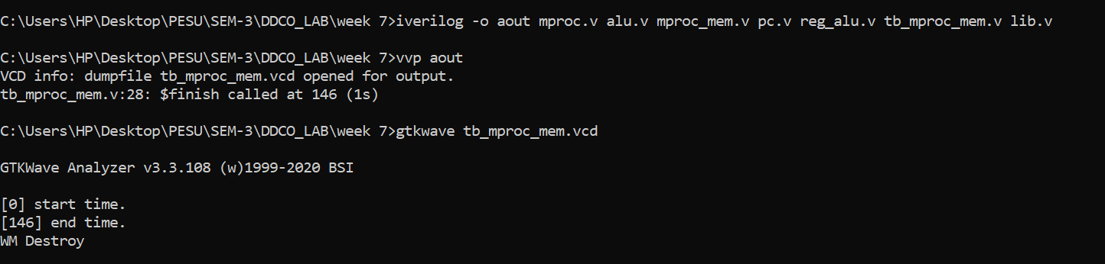

**Gtkwave**

